SOP ID - Number | Quality - 001
Revision | 0.0
SOP Title | Quality Department SOP

 | Name | Title | Signature | Date
Prepared by | Hamza Mehyar | Quality Manager | - | June 25th
Reviewed by
Approved by

Effective Date
Review Date
Next Review Date
Print Date

Read/Used By
Name | Title | Signature | Date

SPECIFIC PROCEDURE

- Tools Used

Tool | Description
Forth CRM | A CRM that contains all the clients files, notations added by agents after each interaction with the client, call logs, and everything related  to the client’s personal info, and debt settlement related files.
RingCX | The current telephony system that contains all the calls recordings.
RingEX | The current telephony system that contains all the calls recordings  for the Sales department only.
MS SharePoint | The SharePoint that’s used to conduct the audit while listening to the  call recording.
Wavepad Software | A specialized sound enhancement software designed to improve the audio quality of low-volume calls, allowing analysts to accurately assess them. To install the software, an IT ticket must be raised for  proper setup and configuration.
Balto AI (QUALITY  Copilot) | An AI system integrated with RingCentral to conduct automatic call audits. The AI evaluates calls based on pre-defined criteria specific  to each QC scorecard.

- Ring Central Manual
RingCX:
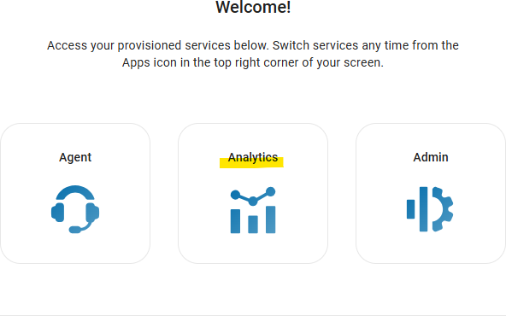
Step 1: Select “Analytics”.
Figure 1
Step 2: Go to “Historical Reports”, then search for and select “Interaction Details”.

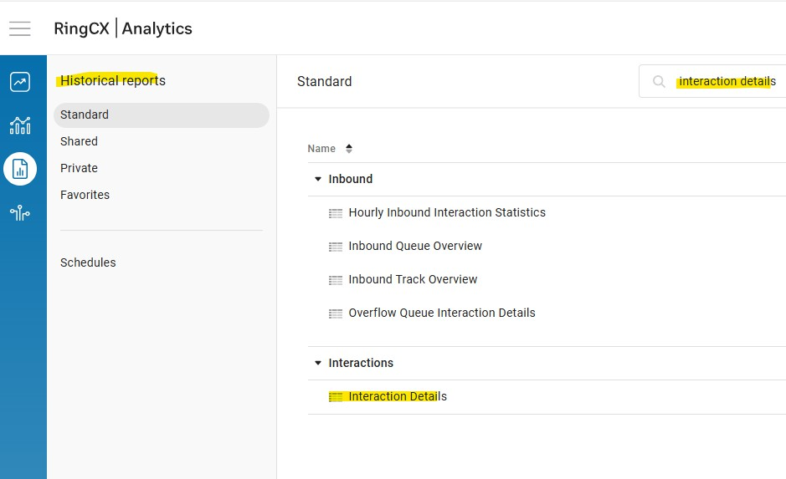

Figure 2

Step 3: Select the following:
- Date Range (a suitable date range, as long date ranges might take a while to load).
- Agent Full Name.

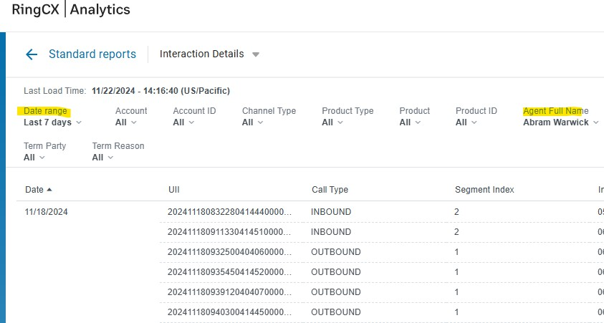

Figure 3

Step 4:
  - Scroll all the way to the right to view the call duration (Interaction Time)
  - Choose a suitable call using the duration as an identifier.
  - Copy the “Recording URL”.

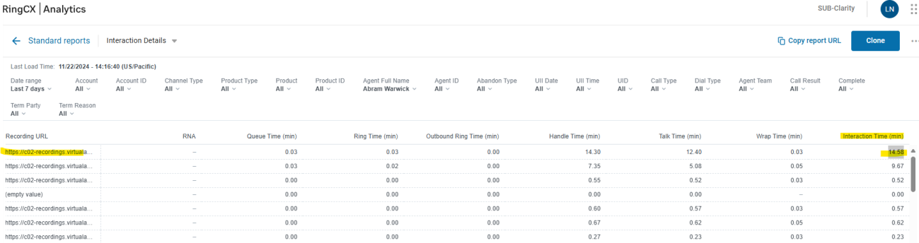
Figure 4

    - Paste the URL link on a different tab.
    - Download the recording.
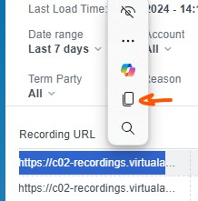
    - Drag and drop it on ‘WavePad’ software to audit.
Figure 5
Step 5: Copy the ANI number to pull up the client’s file on FORTH.

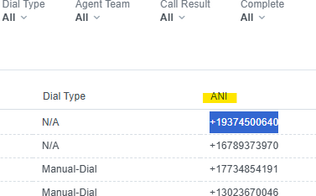

Figure 6

RingEX:
Step 1: Select “Admin Portal”

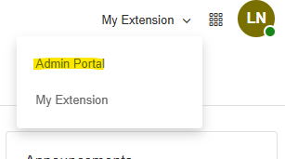
Figure 7
Step 2: Have both (“Analytics” and “Call Log” options open on 2 different tabs)

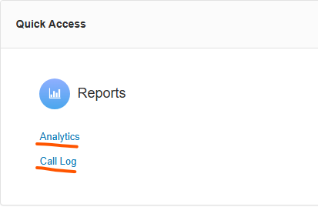

Figure 8

Analytics Tab
Step 1: Select “Performance Reports” Tab

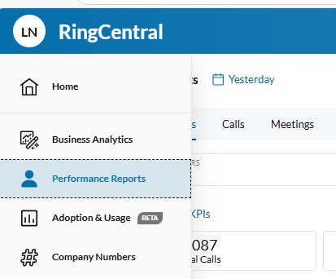
Figure 9
Step 2: Select “Calls” then search for the agent’s name.

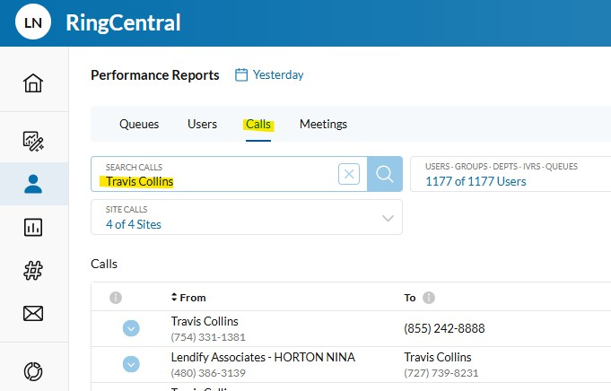

Figure 10

Step 3: Copy the number in the column named “To” and paste it into the Call Log tab that was previously opened.

Note: Use the length of the call as an identifier in the Call Log tab.

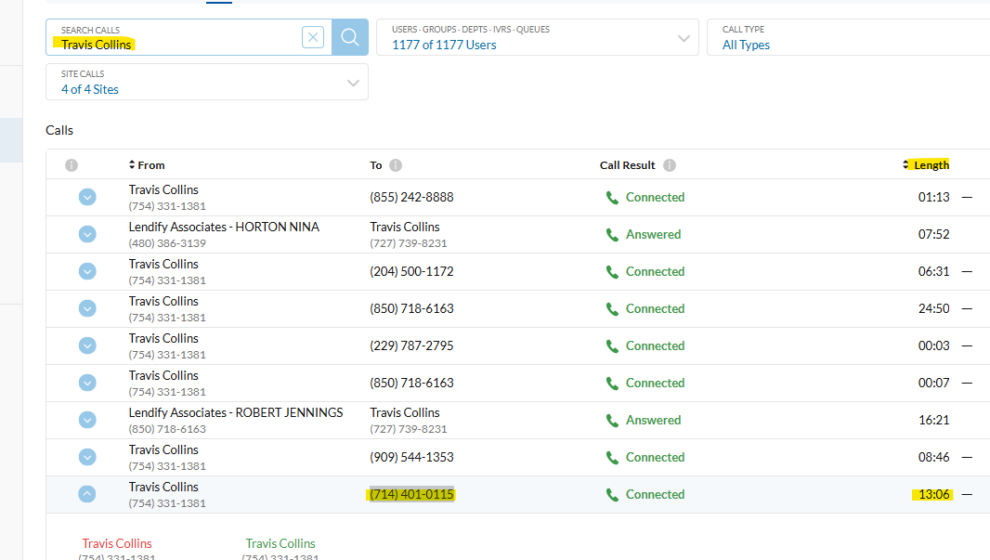

Figure 11

Log Tab
Step 1: Select the filter option (underlined in Red). Step 2: Select the agent’s name by searching for it.
Step 3: Paste the number that was copied earlier as shown below. Step 4: Use the call length as an identifier.

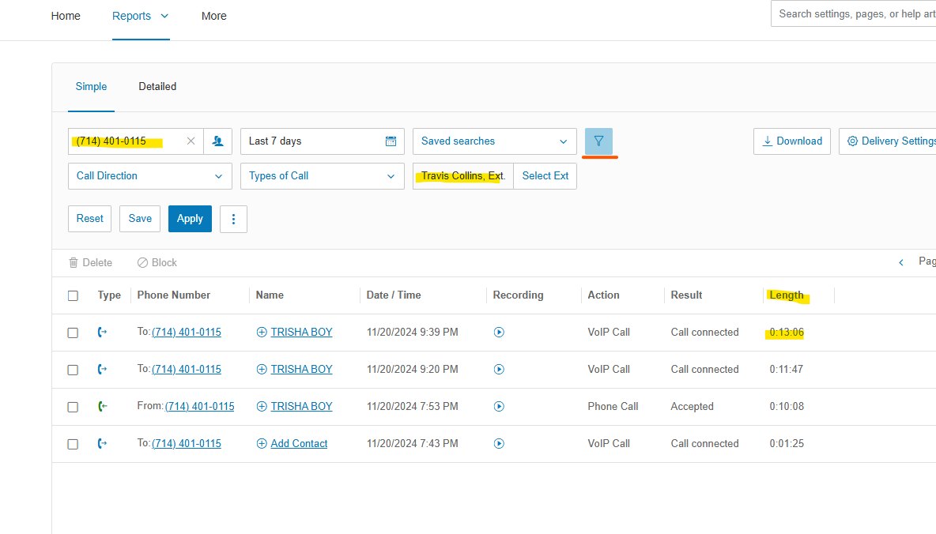
Figure 12

OR
Step 1: Directly click on “Call Log”.
Step 2: Filter the required details as explained previously (Figure 12).
Step 3: The duration of the call - “Length” -can serve as an indicator to help determine if a call is potentially worth reviewing (yet not a definitive measure of the call's value or importance).
Step 4: Call recording can be downloaded by clicking on it (from the “Recording” column). Step 5: Use the number in the “Phone Number” column to pull up the clients file on FORTH.
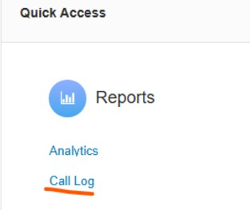
Figure 13

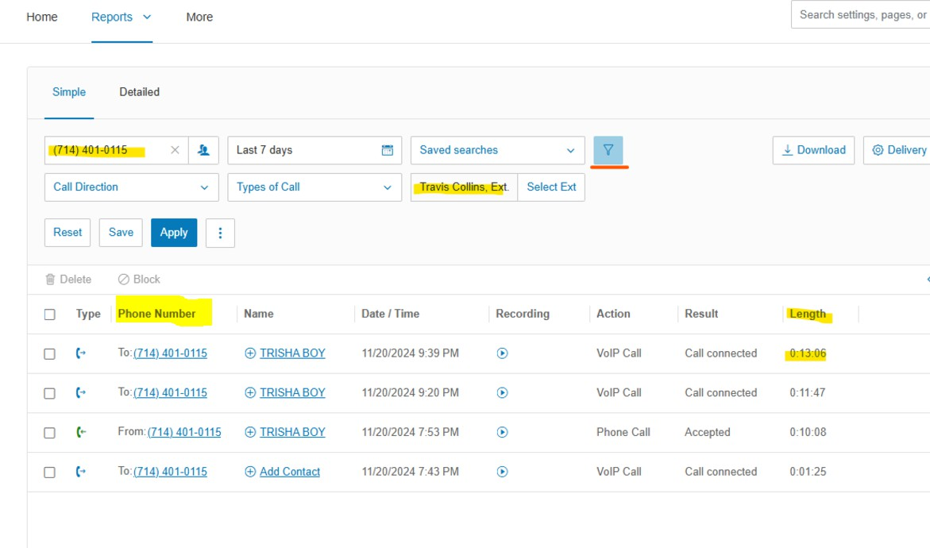
Figure 14
- Quality Success Matrix Grid (SMG)
The Quality Success Matrix Grid outlines the performance expectations and scoring criteria for analysts based on KPIs. The grid is divided into two operational models: Calls Only and Hybrid.

Eligibility Criteria
  - Analysts in their first month of tenure are considered ineligible for evaluation under this matrix.
  - Analysts with less than 12 working days in the month are considered ineligible.
  - If an analyst is out of SMG (for any reason), they are excluded from the incentive plan for that month.

KPIs & Scoring
- Weighted Audits Average VS Weighted Goal
- Description: Measures the number of audits conducted by a QC analyst, adjusted for the effort required based on the Average Handle Time of different call types. Since calls vary in duration, audits are weighted to ensure that longer, more complex calls contribute proportionally more to the analyst's total audit count.
- Calculation Steps:
- Weighted AHT Formula:

Weighted AHT = ((Audit Count for Call Type A×AHT for Call Type A)+(Audit Count for Call Type B×AHT for Call Type B))/ Total Audits Conducted

- Setting Weighted Goals
Goals are established based on the analyst's working hours per day and total workdays in a given period.

- Measure performance:
The analyst’s actual Weighted AHT is compared against their goal.
Variance=Actual Weighted AHT−Goal AHT

Actual Audits Vs Audits Goal | Points
> = 0 | 40
(- 5) - (-1) | 36
(-10) - (-6) | 32
(-15) - (-11) | 28
(-20) - (-16) | 24
(-25) - (-21) | 20
(-30) - (-26) | 16
(-35) - (-31) | 12
(-40) - (-36) | 8
(-45) - (-41) | 4
(-50) - (-46) | 1
< - 50 | 0

- Number of Disputes (out of overall audits per month):
- Description: Measures the percentage of errors identified in audits that were escalated or disputed and identified as valid by the Quality Senior .

Disputes | Points
0% - 1% | 30
>1% | 0

- Audit the Auditor Score (Monthly):
- Description: Performed by the Quality Senior and evaluates the accuracy and quality of the audits performed by the Quality Analyst.

Audit the Auditor Score | Points
100% | 20.00
97% - 99.99% | 17.25
95% - 96.99% | 14.50
92% - 94.99% | 11.75
90% - 91.99% | 9.00
87% - 89.99% | 6.25
85% - 86.99% | 3.50
< 85% | 0.00

- Shrinkage (Unplanned Absenteeism/Month):
- Description: Represents the number of unplanned days of absenteeism/Month. With a threshold of 3 days a month.

Unplanned Leaves SLA:

Shrinkage (Unplanned Leaves) | SLA
Annual Leave | 48 Hours
Sick Leave | 2 Hours
Hourly Leave | 48 Hours

Shrinkage SMG Brackets:

Shrinkage (Unplanned Leaves) | Points
0-1 | 10
2 | 6.67
3 | 3.33
>3 | 0.00

DOCUMENTATIONS AND RECORDS

Record | Purpose | Link
Coaching Request Form (CRF) | A SharePoint to collect requests raised by agents. | CRF
Inbound Client - Audit & Coaching Center | A SharePoint List that contains all the audit data for clients inbound calls. | SharePoint
Inbound Business - Audit & Coaching Center | A SharePoint List that contains all the audit data for business inbound calls. | SharePoint
Outbound Client - Audit & Coaching Center | A SharePoint List that contains all the audit data  for clients’ outbound calls. | SharePoint
Outbound Business - Audit & Coaching Center | A SharePoint List that contains all the audit data for business outbound calls. | SharePoint
Sales - Audit & Coaching Center | A SharePoint List that contains all the audit data for Sales Department. | SharePoint
Legal Sales - Audit & Coaching Center | A SharePoint List that contains all the audit data for Legal Sales. | SharePoint
Affiliates - Audit & Coaching Center | A SharePoint List that contains all the audit data for Affiliates. | SharePoint
Payments Processing - Audit & Coaching Center | A SharePoint List that contains all the audit data for Payments Processing. | SharePoint
Payments (Settlement at Risk) - Audit & Coaching Center | A SharePoint List that contains all the audit data for Payments (Settlement at Risk) division. | SharePoint
Organizational Head count | An up to date excel sheet that outlines the agents in each department. | Excel Sheet
Audit Dispute Form (ADF) | A SharePoint that stores all the disputes raised by team leads/manager across all operational departments. | SharePoint

Audit Dispute Tracker (Team Leads version) | A SharePoint that stores all the disputes raised by team leads/manager across all operational departments, available for other departments. | SharePoint
Calls Scorecard | Calls Scorecard template. | SharePoint
QUALITY Attendance Record | An excel sheet that tracks the absenteeism for QUALITY team. | Excel Sheet
Non-Calls Scorecard | Non-calls Scorecard template. | SharePoint
All Departments Docs | A folder combining all documents we have in the department. | OneDrive
Declined Settlements | A record that shows all the declined settlements by Payments due to a submission error by Negotiations. | SharePoint
Quality Leaves Tracker | A SharePoint List that tracks the absenteeism for QUALITY team. | SharePoint
Additional Assignments/Projects | A SharePoint List that tracks the side project hours for QUALITY team. | SharePoint
Quality Coaching Hub | A SharePoint List that stores the coaching sessions done by the Quality team with agents. | SharePoint
Coaching By Quality Survey | A SharePoint List that stores the evaluations done by agents that have been coached by the Quality Team. | SharePoint

LEGAL AND REGULATORY COMPLIANCE
To be provided by Compliance Department
Explains how compliance with this SOP will be monitored and enforced.
REVISION AND CHANGE HISTORY
- Where the SOP is the initial version:
- SOP No: Record the SOP and version number
- Effective Date: Record effective date of the SOP or “see page 1”
- Significant Changes: State, “Initial version” or “new SOP”
- Previous SOP no.: State “NA”.
  - Where replacing a previous SOP:
- SOP No: Record the SOP and new version number
- Effective Date: Record effective date of the SOP or “see page 1”
- Significant Changes: Record the main changes from previous SOP
- Previous SOP no.: Record SOP and previous version number

SOP No. | Effective Date | Significant Changes | Previous SOP No.

